|  |  |  |  |  |  |
| --- | --- | --- | --- | --- | --- |
|  | 3. TRIGGERS  What triggers customers to act? i.e. seeing their neighbour installing solar panels, reading about a more efficient solution in the news.  *Improve lead generation.  *Reduce customer Service costs.  *Monitor customer Data to gain insights. | TR | 10. YOUR SOLUTION SL  If you are working on an existing business, write down your current solution first, fill in the canvas, and check how much it fits reality.  If you are working on a new business proposition, then keep it blank until you fill in the canvas and come up with a solution that fits within customer limitations, solves a problem and matches customer behaviour  *Instead of navigating many screens for booking products,the user can directy talk to chatbot regarding booking.. | 8.CHANNELS of BEHAVIOUR CH  8.1ONLINE  What kind of actions do customers take online? Extract online channels from #7  *Able to serve customer with the consistent level of quality with the short period of time, across different channels.  8.2OFFLINE  What kind of actions do customers take offline? Extract offline channels from #7 and use them for customer development.  *Make sure they are aware of the use of chatbots. |  |

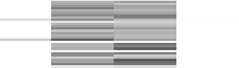Project Title: Project Design Phase-I - Solution Fit Template Team ID: PNT2022TMID02998

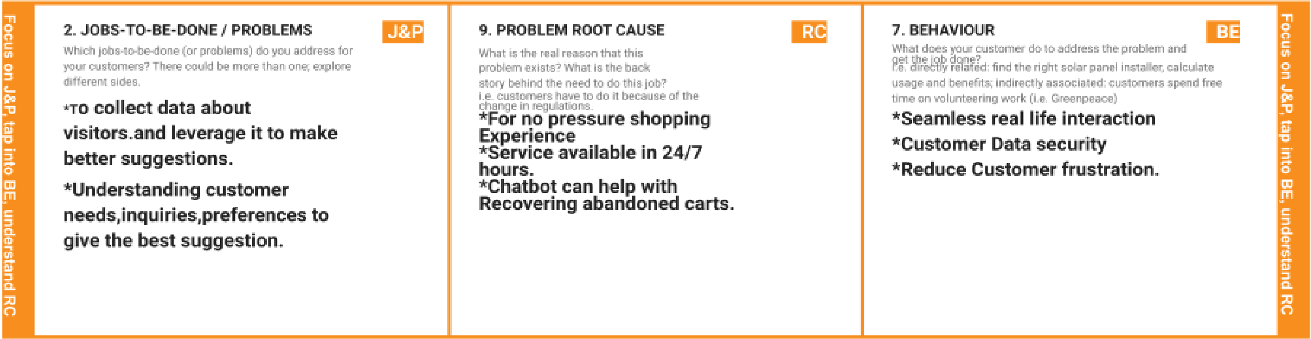



|  |  |  |  |  |
| --- | --- | --- | --- | --- |
|  | 4. EMOTIONS: BEFORE / AFTER EM  How do customers feel when they face a problem or a job and afterwards?  i.e. lost, insecure > confident, in control - use it in your communication strategy & design.  Took longer time to process and respond to the Query. |  |  |  |